SDLC – Create a one page infographic that outlines the SDLC phases highlighting the each phases and how they are interconnected to each other
The Software Development Life Cycle (SDLC) is a structured process used to plan, design, develop, test, and deploy high-quality software. It ensures that each step of software creation is organized, predictable, and aligned with business goals. SDLC is made up of several sequential phases, where each phase depends on the output of the previous one, creating a continuous and interconnected workflow.

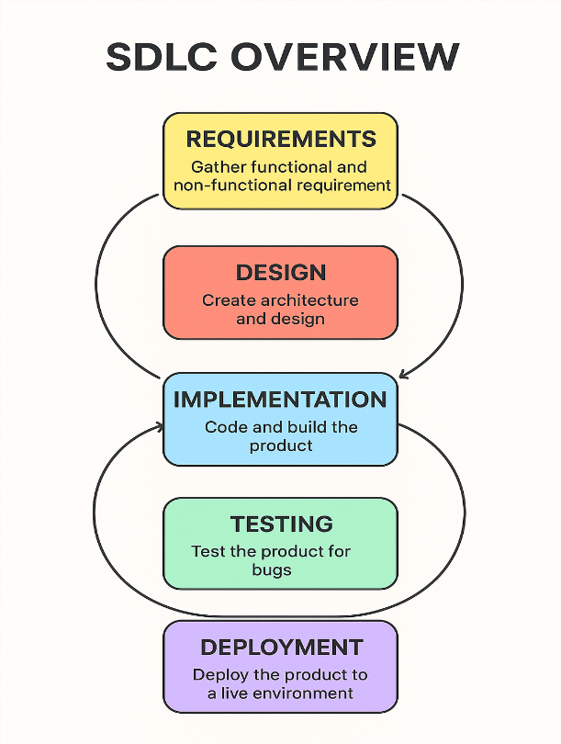
1. Requirement Phase
This is the foundation of the entire SDLC process.
In this phase, stakeholders, users, and analysts gather and document what the system should do.
This includes:
- Functional requirements
- System expectations
- User needs
- Constraints
Connection:
Requirements guide the Design Phase. Without clear requirements, design cannot begin.
2. Design Phase
Based on the requirements, the system architecture and design are created.
This phase includes:
- UI/UX design
- Database design
- System structure
- Technical specifications
Connection:
The design serves as the blueprint for the Implementation Phase. Developers rely on design documents to build the system.
3. Implementation (Development) Phase
In this phase, developers write the actual code to build the system.
Modules are created, integrated, and aligned with the design specifications.
Connection:
Code is then handed over to the Testing Phase to verify functionality.
4. Testing Phase
The developed system is tested to find and fix defects.
Testing ensures:
- Functionality
- Performance
- Security
- User acceptance
Connection:
Once the software passes all tests, it moves to Deployment. Failed tests loop back to the implementation stage for fixing.
5. Deployment Phase
The final software is delivered to users or released to the production environment.
Activities include:
- Installation
- Configuration
- User training
- Monitoring
Connection:
Deployment is often followed by feedback or maintenance, which can send the process back to Requirements for updates.
How the Phases Are Interconnected
Requirements → Design → Implementation → Testing → Deployment
↑ ↓
└────────────────────── Feedback Loop ───────────────┘
- Each phase depends on the output of the previous phase.
- Errors or changes found later send the process back to earlier steps.
- Together, the phases form a continuous cycle of improvement.

